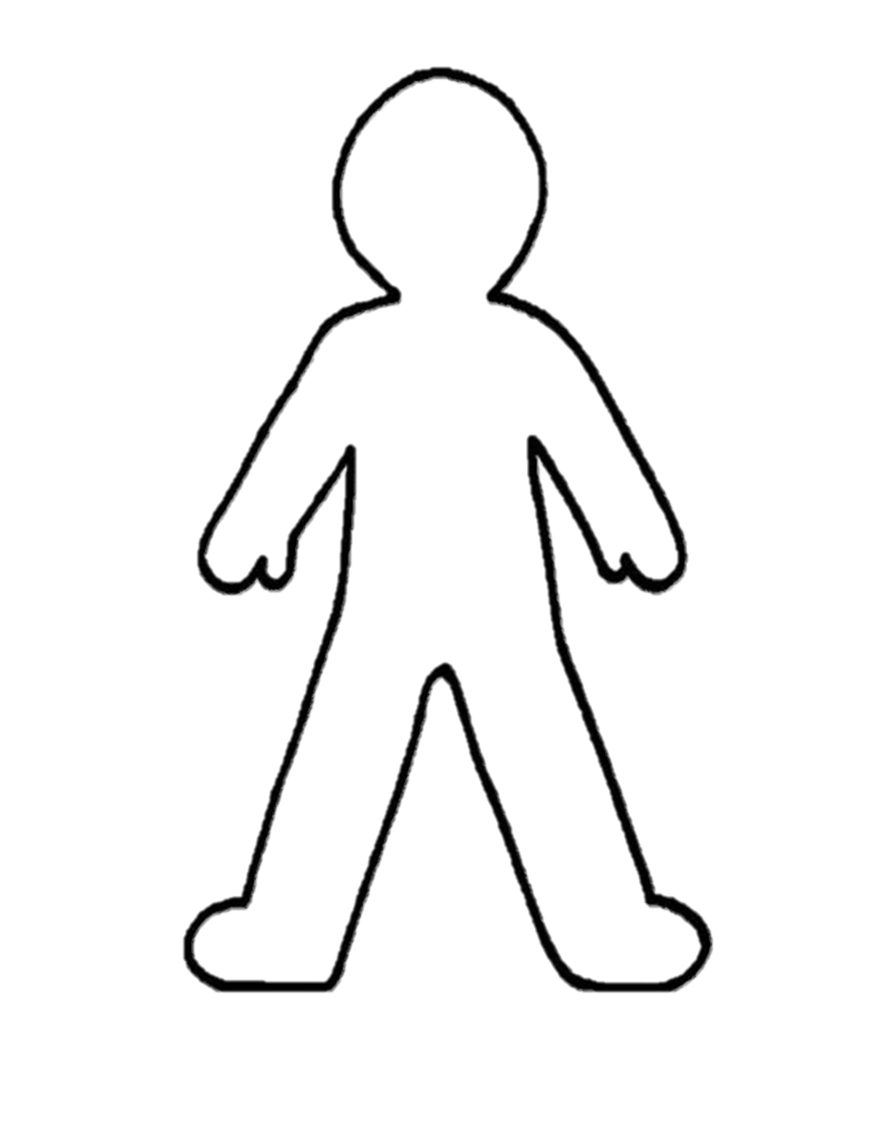

**Body Life Map**

**Head** How would you like to make an impact?

**Heart** Things we feel strongly about OR the people, relationships, things that you love and make you who you are.

**Hands** What you want to create or build.

**Eyes** What you want to see in the future, visions you have for your community.

**Muscles** What are your sources of inspiration, support, strength, power?